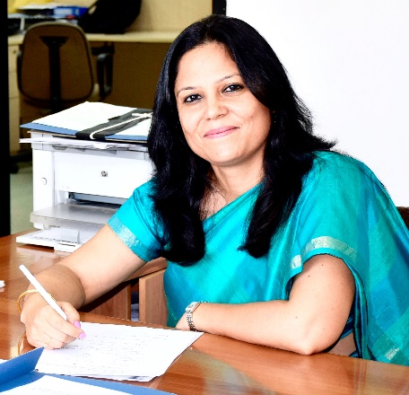
SHORT CV
Dr SHIKHA YADAV
SCIENTIST & HEAD, ANIMAL FACILITY,
NATIONAL INSTITUTE OF BIOLOGICALS,
(Ministry of Health & Family Welfare)
A-32, SECTOR -62,
NOIDA, UP
Dr.Shikha Yadav had initiated her research career at Genes and Proteins Laboratory of National Institute of Immunology, Delhi in 2000, after which she started working in the field of laboratory animal science as veterinarian at National Brain Research Centre (DBT),Ministry of Science & Technology, ,Manesar in 2002.Here she had got the rare opportunity of establishing a new animal facility and working with a large number of laboratory animal species and strains including laboratory rats, mice ,transgenic and knockout mice ,G .Pigs, rabbits, Zebra Finches and non-human primates (Rhesus and bonnets). In 2009, she joined as a scientist and Head of Animal Facility at National Institute of Biologicals (Ministry of Health and Family Welfare), Noida which is a premier Scientific Organization and a Centre of Excellence to ensure quality of biologicals and vaccines being imported or manufactured in the country. During her 18 years of experience in management of Animal Facilities, she has established 2 state of art Animal Facilities i.e of NBRC, Manesar and NIB.
She has been nominated as a member of Institutional Animal Ethics Committee (IAEC) of several institutes by CPCSEA which enables her to ensure proper care, use and humane treatment of animals used in research, education or testing in these institutes and also ensure compliance to the guidelines, regulations and policies framed by CPCSEA.She is also invited as a guest faculty in several training programs to give talks on various aspects of laboratory animal science and animal welfare including the only FELASA accredited course in India i.e “Certificate course in Laboratory Animal Science” organized by TANUVAS, Chennai every year, JNU, Delhi, MDU, Rohtak, Delhi University etc. and has also organised a number of such trainings at NIB, for postgraduate students and participants from all over the country. She has also been selected as an Adhoc Specialist by the Association for Assessment and Accreditation of Laboratory Animal Care, International (AAALAC International).

